Investigative Question:
What geologic structures or bedrock properties are present in the Lehigh Gorge and do these features influence the current position of the Lehigh River and its tributaries?

Activity 1: Big Picture
Answer the following questions in complete sentences. Links are provided below to assist you in your explorations.

1. In what geologic province(s) of Pennsylvania is the Lehigh Gorge located?

2. What are the characteristic features of the bedrock in this region of Pennsylvania?

3. How is this province different from the coastal plain?

Examine the satellite image below of the folded rocks of the Appalachian Mountains.
4. How would you describe the features shown on the map? Do you see any trends?

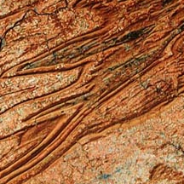

The links below will help you answer the questions
http://www.dcnr.state.pa.us/topogeo/maps/map13.pdf (province map)
http://www.usgs.gov/ (USGS site)
http://www.dcnr.state.pa.us/topogeo/ (Pa geologic survey link)

Activity 2: Bedrock

An interesting section of sedimentary rock has been exposed by the Lehigh River. The river has carved out a “window” in the bedrock that allows geologist an opportunity to examine several different layers. In this section you will examine the ages and types of bedrock present in the Lehigh Gorge.

1. What are the names and ages of the bedrock exposed in the Lehigh Gorge? List them in order of oldest to youngest rock type.

2. What symbols represent each bedrock unit? How do the symbols represent the age of the bedrock?

All of the rocks in the Lehigh Gorge are sedimentary and were formed millions of years ago. Examine the pictures of each rock type and their descriptions. Note the similarities and differences between the physical properties of each rock type.

3. What type of rock is predominant in the Pocono Formation? What are its characteristics?

4. How would you describe the grain size of the Mauch Chunk sandstone compared to the Pocono Formation?

5. How many different rock types compose the Spechty Kopf formation? How do you think this affects its ability to resist erosion?

6. Which bedrock unit does the Lehigh River erode through easily? Which properties of this bedrock unit make it “weaker” than the others?

7. What depositional environment would produce conglomerate? Sandstone? Shale? Mudstone?

Activity 3: How are sediments deposited?
Please read the following statements describing how sedimentary layers are deposited.
STENO'S LAWS
Principle of Superposition, states that in an undisturbed sedimentary sequence, the older beds are on the bottom, and the younger beds are on the top.
Principle of Original Horizontality, states that sediments are deposited in flat, horizontal layers. Sedimentary particles settling under the influence of gravity in a body of water will deposit horizontal layer of sediment.
Principle of Original Lateral Continuity. If we assume that sediment is being deposited on the seafloor, the sediment will not only be deposited in a flat layer, it will be a layer that extends for a considerable distance in all directions. The layer is said to be laterally continuous.

These three laws apply to the sediments forming the bedrock units within the Lehigh Gorge. Many times rock units contain “bedding” that is viewed as a layered look to the rocks. A bedding plane is a surface separating layers of sedimentary rock. Examine the bedding shown below.

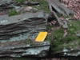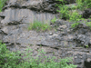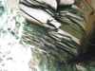
.

Use the pictures provided to answer the following questions in complete sentences.

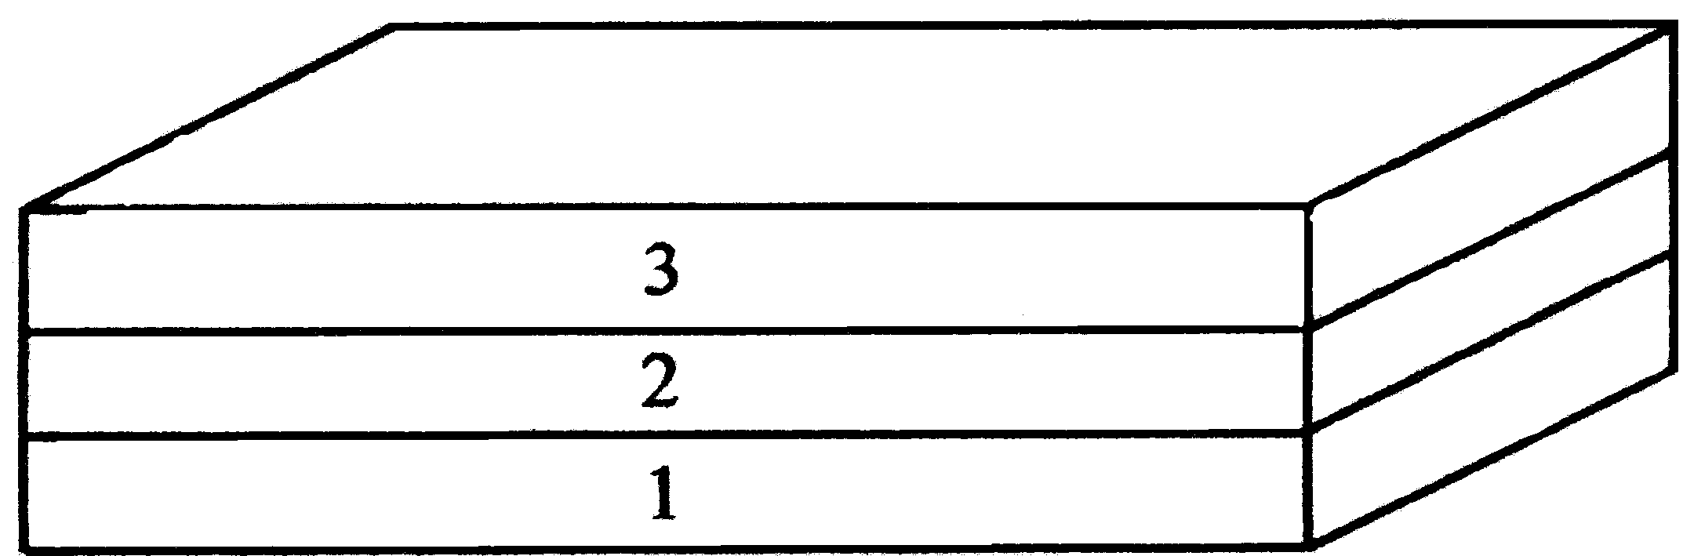

1. Look at the picture above, which rock layer is the oldest and which is the youngest?

Many times layers of rock are not observed as horizontal sheets. Sometimes they are compressed, extended or sheered in opposite directions. These forces distort the horizontal layers and produce different folds or cracks in rock layers.

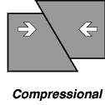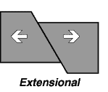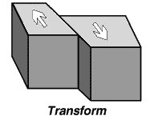

When rock is compressed, sometimes the layers bend and form folds. An anticline is a fold in which the layers (limbs) dip away from the axis or center of the fold. The picture on the left (A) is an anticline. A syncline is a fold in which the layers (limbs) dip toward the axis or center of the fold. The picture on the right (B) is a syncline.

Anticline Syncline

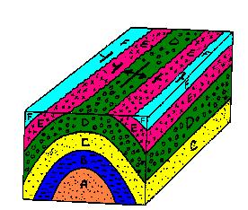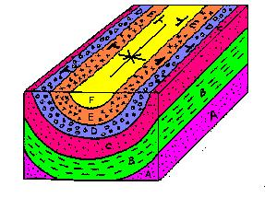
A B

Examine the pictures of folded bedrock. Using your knowledge of Steno’s laws, answer the following questions in complete sentences. Note the symbols for an anticline and syncline. An anticline is shown by a line representing the axis or center of the fold and arrows pointing away from each other, the arrows are pointing toward each other in the syncline symbol

2. In picture A, which layer is the oldest and which layer is the youngest?

3. In picture B, which layer is the oldest and which layer is the youngest?

Use the picture of the anticline to answer the following question.
4. If you stand at the center of an anticline and walk perpendicular to the fold axis, are the rocks you cross over younger or older than the rock exposed in the center of the anticline? (Imagine walking from the green rock layer in a straight line to the aqua colored rock layer)

Use the picture of the syncline to answer the following question.
5. If you stand at the center of a syncline and walk perpendicular to the fold axis, are the rocks you cross over younger or older than the rock exposed in the center of the syncline? (Imagine walking from the yellow rock layer in a straight line toward the pink rock layer)

Look at the bedrock map of the Lehigh Gorge.

6. Are the rock layers in the Lehigh Gorge horizontal? Explain your answer.

7. What must have happened to the bedrock to form the pattern you see in the Lehigh Gorge?

Activity 4: Use your knowledge
Use the following map to answer the questions below. You may print the map and place the marks directly on your paper.

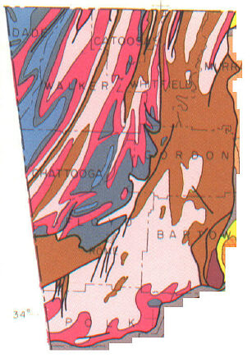

 Pennsylvanian rocks
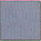 Mississippian Rocks
 Devonian Rocks
 Ordovician Rocks
 Cambrian Rocks

1. On your printed map find the axis (shown below) or center of an anticline and a syncline and mark them with a line. Place the correct symbol on your map to designate an anticline and a syncline.

Examine the common geologic map symbols on a bedrock map. http://wrgis.wr.usgs.gov/docs/parks/gmap/gmap3.html

Common symbols found on a geologic map include strike and dip symbols. These symbols tell the geologist or reader the direction a bed is trending and the angle at which the bed is positioned compared to the horizontal (generally the Earth’s surface). Read the following definitions and go to the Website below to explore strike and dip.
http://www.geology.sdsu.edu/visualgeology/geology101/geodip.htm

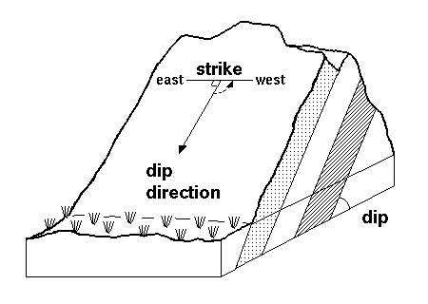

2. On your printed bedrock map, place strike and dip symbols where you would expect to find them on the flanks of your anticline and syncline. (You don’t need a dip angle)
Activity 5: Bring it all together

Read the following questions and answer in at least one paragraph. Review your previous answers to help you form complete thoughts about the process or reasons for why the Lehigh River is in its present position.

1. What geologic structures or bedrock properties have had an influence on the current position of the Lehigh River? Why does the river flow in the pattern you see at the present time?

2. What was the sequence of events that produced the Lehigh Gorge starting from bedrock formation to the current position of the Gorge today?

